# Archer Due Diligence Management

The Archer Due Diligence Management app-pack provides a consistent and repeatable process for due diligence, which helps legal teams during mergers and acquisitions. The Archer Due Diligence Management app-pack helps organizations to track due diligence projects and activities required to complete due diligence. It also tracks the approvals and defines the framework for due diligence.

On this page

* Release notes
* Overview of Archer Due Diligence Management
  + Key features and benefits
  + Prerequisites (ODA and system requirements)
  + Compatible use cases and applications
    - Related applications
* Archer Due Diligence Management components
  + Architecture diagram
  + Swim lane diagram
  + Applications
  + Personas and access roles
  + Permissions Chart
* Installing Archer Due Diligence Management
  + Installation overview
    - Task 1: Prepare for the installation
    - Task 2: Install the package
    - Task 3: Set up data feeds
    - Task 4: Test the installation
  + Installing the package
    - Task 1: Back up your database
    - Task 2: Import the package
    - Task 3: Map objects in the package
    - Task 4: Install the package
    - Task 5: Review the package installation log
    - Task 6: Activate advanced workflow
  + Setting up data feeds
* Using Archer Due Diligence Management
  + Task A: Define Due Diligence framework
  + Task B: Perform Due Diligence
    - Task 1: Create Due Diligence project
    - Task 2: Generate Due Diligence checklist
    - Task 3: Assign, track, and complete Due Diligence checklist
    - Task 4: Submit Due Diligence project
    - Task 5: Review Due Diligence project
    - Task 6: Resubmit
    - Task 7: Export mail merge document
* Certification environment

## Release notes

| Archer Version | Published Date | Notes |
| --- | --- | --- |
| 6.5 | February 2019 | Initial Release |
| 6.13 | July 2023 | Recertification |

## Overview of Archer Due Diligence Management

### Key features and benefits

Archer Due Diligence Management enables organization to:

* Determine the due diligence requirements
* Track due diligence tasks to completion
* Confirm and verify information through investigation
* Provide recommendations based off factual data and reports

The Archer Due Diligence Management app-pack provides a:

* Consistent and repeatable process for conducting due diligence
* Implement structure for due diligence checklist
* Obtain visibility into the status of the due diligence activities required

### Prerequisites (ODA and system requirements)

| Components | Prerequisites |
| --- | --- |
| Archer Requirements | Archer 6.13 and later |
| Requires On-Demand License | Yes. The Archer Due Diligence Management App-Pack requires three (3) On-Demand Applications license. |
| Archer Applications | * Due Diligence Checklist * Due Diligence Framework * Due Diligence Project |
| Pre-requisite Applications | Requirements for the installation and operation of Archer Due Diligence Management includes the following use cases:   * Findings– Archer Issues Management * Exception Requests– Archer Issues Management * Remediation Plans– Archer Issues Management |

### Compatible use cases and applications

#### Related applications

| Application | Use Case | Primary Purpose(s) of the Relationship |
| --- | --- | --- |
| Business Unit | IT Asset Catalog, Business Asset Catalog | * Relate Due Diligence Project to Business Unit |
| Authoritative Sources | Policy Program Management, Controls Monitoring Program Management | * Relate Due Diligence requirements to Authoritative Sources |

## Archer Due Diligence Management components

### Architecture diagram

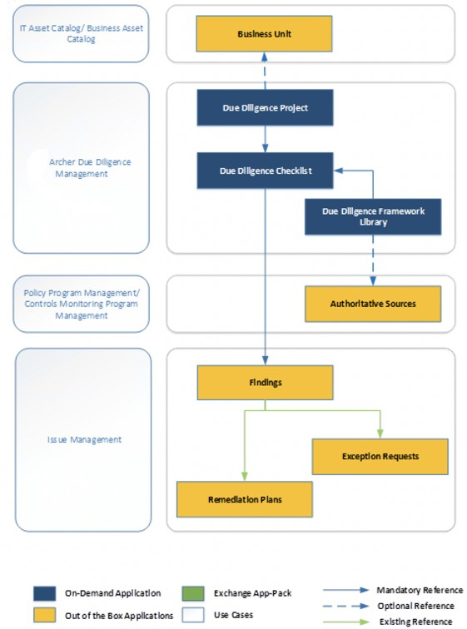

### Swim lane diagram

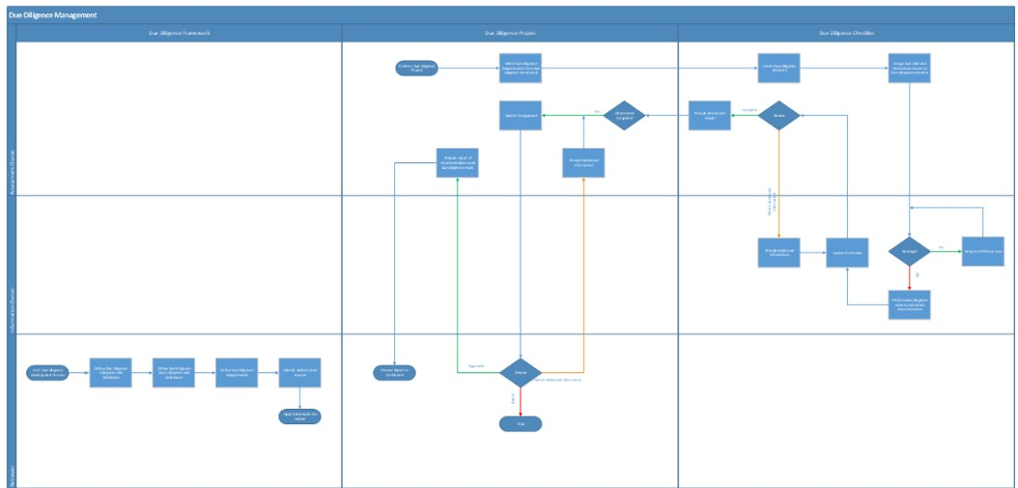

Due Diligence Framework:

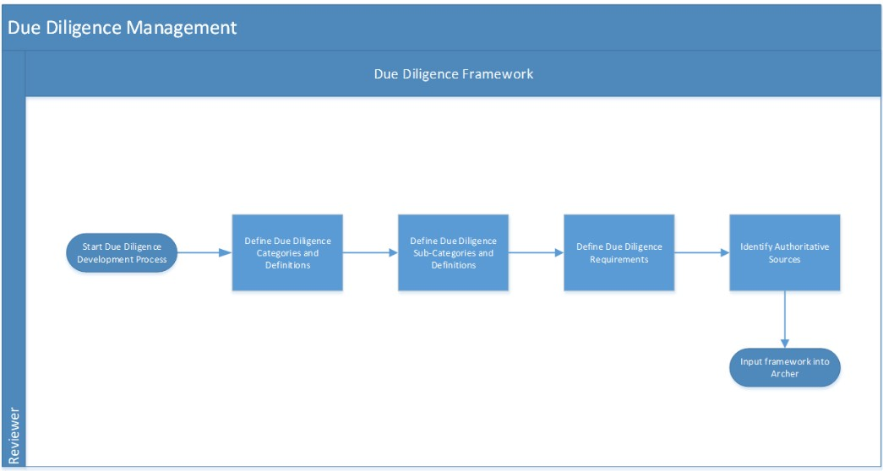

Due Diligence Profile:

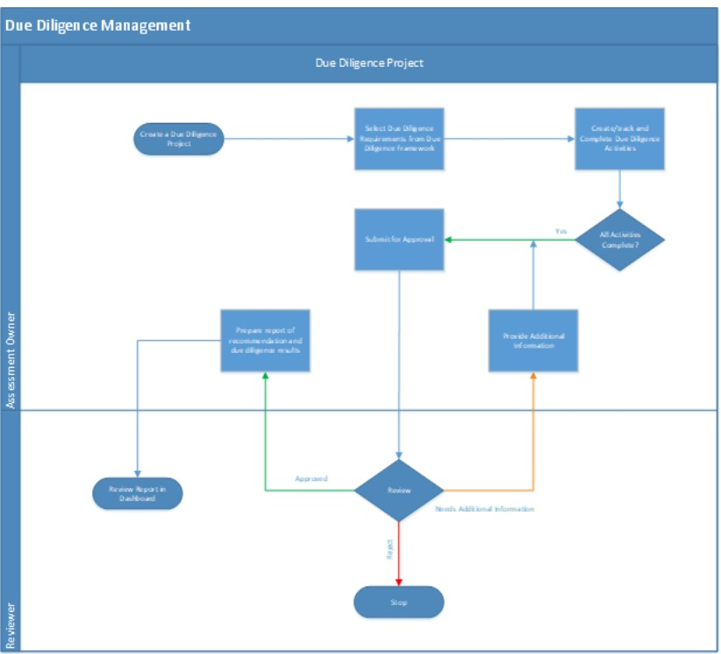

Due Diligence Checklist:

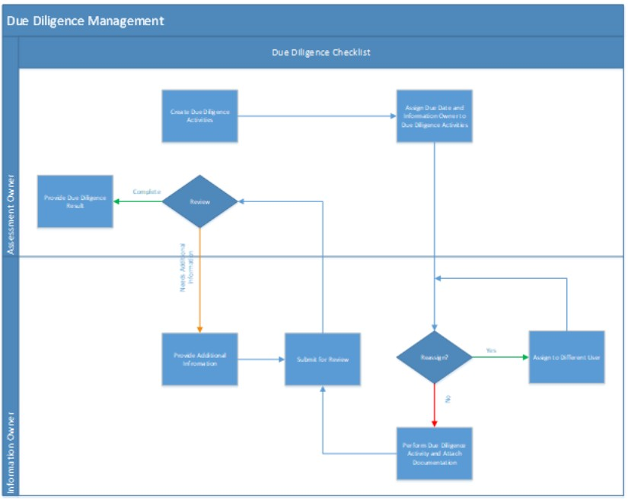

### Applications

| Application | Description |
| --- | --- |
| Due Diligence Framework | The Due Diligence Framework application contains the framework for the due diligence requirements. The framework is a leveled application and is structured by Category, Sub Category, and Requirement. The requirement can be tied to an Authoritative Source. |
| Due Diligence Project | The Due Diligence Project application captures meta-data (e.g., type of due diligence project, information regarding the target, financial information, and stakeholders), workflow approvals, due diligence checklist, and summary. |
| Due Diligence Checklist | The Due Diligence Checklist application contains the due diligence activities performed on the due diligence projects. It captures the Information Owner, evidence of the due diligence activity, and due diligence results. |

### Personas and access roles

The following table describes the functions that make up the application’s organization roles. Depending on the organization of your company, these functions and responsibilities may vary.

| Persona | Description | How many? | Optional / Required |
| --- | --- | --- | --- |
| Assessment Owner | Responsible for defining the scope of due diligence, assigning due diligence activities, and providing a report of recommendation based upon due diligence performed. This person can be in the same or different department as the other personas. Possibly someone from the Legal department. | At least one, likely multiple | Required |
| Information Owner | Assigned tasks to provide supporting documentation to fulfill due diligence requirements. Can own one or many activities. This person can be in the same or different department as the other personas. | At least one, likely multiple | Required |
| Reviewer | Responsible for the overall approval of due diligence conducted. This role would be someone with approval authority, possibly someone from Legal management. | At least one, likely multiple | Required |

### Permissions Chart

| Applications | Due Diligence: Assessment Owner | Due Diligence: Information Owner | Due Diligence: Reviewer | Due Diligence: Read Only |
| --- | --- | --- | --- | --- |
| Due Diligence Project | CRU | R | RU | R |
| Due Diligence Checklist | RU | RU | RU | R |
| Due Diligence Framework | R | R | CRU | R |
| Findings | CRU | CRU | CRU | R |
| Remediation Plans | CRU | CRU | CRU | R |
| Exception Requests | CRU | CRU | CRU | R |
| Business Unit | R | R | R | R |
| Authoritative Sources | R | R | R | R |

C = Create, R = Read, U = Update, D = Delete

## Installing Archer Due Diligence Management

### Installation overview

Complete the following tasks to install the offering.

#### Task 1: Prepare for the installation

1. Ensure that your Archer system meets the following requirements:
   * Archer Platform version 6.13
2. Download the ODA install package from the Archer Exchange Link:<https://www.archerirm.community/t5/exchange-downloads/archer-due-diligence-management-6-5-app-pack-installation/ta-p/566150>
3. Read and understand the "Packaging Data" section of Archer Help.

#### Task 2: Install the package

Installing a package requires that you import the package file, map the objects in the package to objects in the target instance, and then install the package. See Installing the Application Package for complete information.

#### Task 3: Set up data feeds

You must import and schedule each use case data feed that you want to use. See Setting Up Data Feeds for complete information.

#### Task 4: Test the installation

Test the application according to your company standards and procedures, to ensure that the use case works with your existing processes.

### Installing the package

#### Task 1: Back up your database

There is no Undo function for a package installation. Packaging is a powerful feature that can make significant changes to an instance. Archer strongly recommends backing up the instance database before installing a package. This process enables a full restoration if necessary.

An alternate method for undoing a package installation is to create a package of the affected objects in the target instance before installing the new package. This package provides a snapshot of the instance before the new package is installed, which can be used to help undo the changes made by the package installation. New objects created by the package installation must be manually deleted.

#### Task 2: Import the package

1. Go to the Install Packages page.
   1. From the menu bar, click Admin menu.
   2. Under Application Builder, click Install Packages.
2. In the Available Packages section, click Import.
3. Click Add New, then locate and select the package file that you want to import.
4. Click OK.

The package file is displayed in the Available Packages section and is ready for installation.

#### Task 3: Map objects in the package

1. From the menu bar, click Admin menu > Application Builder > Install Packages.
2. In the Available Packages section, locate the package you want to map.
3. In the Actions column, click Map package for that package.

* The analyzer examines the information in the package. The analyzer automatically matches the system IDs of the objects in the package with the objects in the target instance and identifies objects from the package that are successfully mapped to objects in the target instance, objects that are new or exist but are not mapped, and objects that do not exist (the object is in the target but not in the source).
* When the analyzer is complete, the Advanced Package Mapping page lists the objects in the package file and corresponding objects in the target instance.

1. On the Advanced Mapping page, click to open each category and review the icons next to each object to determine which objects you must map manually.

The following table describes the icons.

| Icon | Name | Description |
| --- | --- | --- |
| Awaiting mapping review | Awaiting Mapping Review | Indicates that the system could not automatically match the object or one of its children to a corresponding object in the target instance.  Objects marked with this icon must be mapped manually.  New objects should not be mapped. Select Do Not Map from the drop-down menu to clear this icon for an individual object, or click Do Not Map to clear the icon for all unmapped objects. |
| Mapping completed | Mapping Completed | Indicates that the object and all children are mapped to objects in the target instance, or that they have been marked as Do Not Map. Nothing more needs to be done with these objects in Advanced Package Mapping. |

* **Note:** You can run the mapping process without mapping all objects. The Awaiting mapping review icon is for informational purposes only.

1. For objects awaiting mapping review, do one of the following:
   * To map each object individually, use the drop-down menu in the Target column to select the object in the target instance to which you want to map the source object. To leave an object unmapped, select Do Not Map in the Target column.
   * To automatically map all objects in a category that have different system IDs but the same object name as an object in the target instance, click Auto Map. Select whether to ignore case and spaces when matching object names. Click OK.
   * To mark all unmapped objects as Do Not Map, click Do Not Map.
2. (Optional) Click Filter to enable filter fields that you can use to find specific objects in each mapping category. To undo your mapping selections, click Undo, then select whether to undo all mappings in the category or only the mappings on a single page. If you choose to undo all mappings, you will be returned to the categories list.
3. (Optional) To save your mapping selections and return to the categories list without committing changes to the target instance, click RSA.
4. After you review and map all objects, click Execute.
5. Select I understand the implications of performing this operation. Click OK.

* When the mapping is complete, the Import and Install Packages page displays.
* **Important:** Advanced Package Mapping modifies the system IDs in the target instance. You must update any Data Feeds and Web Service APIs that use these objects with the new system IDs.

#### Task 4: Install the package

All objects from the source instance are installed in the target instance unless the object can not be found or is flagged to not be installed in the target instance. A list of conditions that may cause objects not to be installed is provided in the Log Messages section. A log entry is displayed in the Package Installation Log section.

1. Go to the Install Packages page.
   1. From the menu bar, click Admin menu.
   2. Under Application Builder, click Install Packages.
2. In the Available Packages section, locate the package file that you want to install, and click Install.
3. In the Configuration section, select the components of the package that you want to install.
   * To select all components, select the top-level checkbox.
   * To install only specific global reports in an already installed application, select the checkbox associated with each report that you want to install.

**Note:** Items in the package that do not match an existing item in the target instance are selected by default.

1. In the Configuration section, under Install Method, select an option for each selected component. To use the same Install Method for all selected components, select a method from the top-level drop-down list.

**Note:** If you have any existing components that you do not want to modify, select Create New Only. You may have to modify those components after installing the package to use the changes made by the package.

1. In the Configuration section, under Install Option, select an option for each selected component. To use the same Install Option for all selected components, select an option from the top-level drop-down list.

**Note:** If you have any custom fields or formatting in a component that you do not want to lose, select Do not Override Layout. You may have to modify the layout after installing the package to use the changes made by the package.

1. To deactivate target fields and data-driven events that are not in the package, in the Post-Install Actions section, select the Deactivate target fields and data-driven events that are not in the package checkbox. To rename the deactivated target fields and data-driven events with a user-defined prefix, select the Apply a prefix to all deactivated objects checkbox, and enter a prefix. This can help you identify any fields or data-driven events that you may want to review for clean up post-install.
2. Click Install.
3. Click OK.

#### Task 5: Review the package installation log

1. Go to the Package Installation Log tab of the Install Packages page.
   1. From the menu bar, click Admin menu.
   2. Under Application Builder, click Install Packages.
   3. Click the Package Installation Log tab.
2. Click the package that you want to view.
3. In the Package Installation Log page, in the Object Details section, click View All Warnings.

#### Task 6: Activate advanced workflow

1. Go to the Applications page.
   1. From the menu bar, click Admin menu.
   2. Under Application Builder, click Applications.
2. In the Applications section, select the Due Diligence Project Application.
3. On the Advanced Workflow Tab, click ‘Activate’ in the top right corner of the page.
4. Then click ‘Save Workflow’ in the top left corner of the page.

### Setting up data feeds

One Data Feed is included in the Archer Due Diligence Management app-pack package:

Datafeed: Create Due Diligence Checklist Activities: The following feed will create Due diligence activities based on the requirements selected in the Project.

1. Go to Manage Data Feeds page:
   1. From the menu bar, click Admin menu.
   2. Under Integration, click Data Feeds.
2. Locate and select the Data Feed.
3. Verify settings in the General tab.
   1. In the General Information section, set the Status field to Active.
   2. In the Feed Information section, confirm that the Target field is set to IoT Profiles.
4. Click the Transport tab.
   1. In the Transport section, confirm that the Transport Method field is set to Archer Web Services Transporter.
   2. In the Security section, in the URL field, insert the URL to your instance.
   3. In the Transport Configuration section, do the following:
      1. In the User Name and Password fields, type the username and password of a Platform user.
      2. In the Instance field, enter the name of your instance.
5. Verify the settings on the Source Definition tab. This will be pre-configured.
6. Verify the settings and mappings on the Data Map tab. This will be pre-configured.
7. The Key Definition fields should be pre-populated based on the information from the imported Data Feed.
8. The final configuration step is to schedule the data feed. Click the Schedule tab and configure the frequency and start time of the Data Feed.
9. Click Save to apply your configuration to the data feed.
10. (Optional) To override the data feed schedule and immediately run your data feed, in the Run Data Feed Now section, click Start.
11. Click the Run Detail link for additional information on the status of the feed or to troubleshoot any feed errors.

## Using Archer Due Diligence Management

### Task A: Define Due Diligence framework

Users: Reviewer

1. Go to Due Diligence Framework Add New Record dialog box.
   1. From menu bar, click on the drop-down beside Due Diligence Management.
   2. Under Solutions, select Due Diligence Management.
   3. Under Applications, select Due Diligence Framework.
   4. In the Due Diligence Framework record browser, click New Record.
2. To define a Category:
   1. Select Category and click Continue in the Add New Record dialog box.
   2. Provide Category, Category Description, and Framework Version in the“General Information” section.
   3. Click Save in the record toolbar.
3. To define a Sub Category:
   1. Select Sub Category and click Continue in the Add New Record dialog box.
   2. Provide Sub Category, Sub Category Description, Framework Version, and Category Reference(s)in the “General Information” section.
   3. Click Save in the record toolbar.
4. To define a Requirement:
   1. Select Requirement and click Continue in the Add New Record dialog box.
   2. Provide Requirement, Requirement Description, Risk Category, Framework Version, and select Sub Category Reference(s), related Authoritative Sources in the “General Information” section.
   3. Click Save in the record toolbar.

### Task B: Perform Due Diligence

#### Task 1: Create Due Diligence project

Users: Assessment Owner

1. Go to Due Diligence Project record.
   1. From the menu bar, click on the drop-down beside Due Diligence Management.
   2. Under Quick Links, click Create New Due Diligence.
2. Enter the Project Name, Project Description, Target Contact, Target Address, Location, Type of Business, Stakeholders, Start Date, and End Date in the “General Information” section.
3. Select the reviewer in the Reviewer field in the “Workflow and Approvals” section.
4. Provide financial information details related to the project on the Financial Information tab.
5. Click Save in the Record Toolbar.

#### Task 2: Generate Due Diligence checklist

Users: Assessment Owner

1. Navigate to the Due Diligence tab in Due Diligence Project record.
2. Select requirements in the Due Diligence Requirement field in the “Due Diligence Requirements” section.
3. Click the Generate Checklist button in the top left of the screen.
4. Due Diligence Requirements will be populated in the “Due Diligence Checklist” section.

#### Task 3: Assign, track, and complete Due Diligence checklist

Users: Assessment Owner, Information Owner

1. Assessment Owner will assign Information Owner to the Due Diligence checklist.
   1. Navigate to the Due Diligence tab in Due Diligence Project record.
   2. If the record is in view mode, click on Enable Inline Edit on the right corner of the “Due Diligence Checklist” section.
   3. Select Priority, Due Date, and Assigned To for the requirements in the “Due Diligence Checklist” section.
   4. Click on Save at the end of the row.
2. Information Owner will submit/reassign the Due Diligence checklist.
   1. Navigate to the Due Diligence Checklist Record:
      1. From the menu bar, click on the drop-down beside Due Diligence checklist.
      2. Under dashboards, select Information Owner Dashboard.
      3. Click on Requirement, in “My Open Due Diligence Checklist Activities.”
   2. Click on Edit.
   3. Attach the documentation related to Due Diligence Activity in the “Related Documents” section.
   4. Add Information Owner Comments in the “Workflow and Approvals” section.
   5. If Overall Status is Not Started or Needs Additional Information, Information Owner will Change Submission Status to Submitted/Resubmitted/Reassign in the “Workflow and Approvals” section.
      1. If the Information Owner is incorrect, change Overall Status to Reassigned and select new Information Owner. The new Information Owner will be notified after saving the record and will repeat step 2.
      2. If the Due Diligence Activity has been completed, change the Overall Status to Submitted or Resubmitted and the Assessment Owner will be notified after saving the record.
   6. Click on Save.
3. Assessment Owner will review the requirements in the Due Diligence checklist.
   1. Navigate to the Due Diligence tab in the Due Diligence Project record.
   2. If the record is in view mode, click on Enable Inline Edit on the right corner of the “Due Diligence Checklist” section.
   3. Verify the attachment under Related Documents column and Information Owner Comments column, if any.
   4. If Overall Status is submitted, Assessment Owner Status can request additional information or complete the requirement:
      1. To request additional information:
         1. Change Assessment Owner Status to Needs Additional Information and provide Assessment Owner Comments in the “Workflow and Approvals” section. Click on Save at the end of the row.
         2. Overall Status will change to Needs Additional Information.
      * **Note:** If Assessment Owner Review Status is Needs Additional Information and you want to request additional information again, change Assessment Owner Review Status to Awaiting Review and click on save. Then you can change the Assessment Owner Review Status to Needs Additional Information again to request additional information.
      1. To complete the Due Diligence Activity:
         1. Change Assessment Owner Status to Complete and Select Due Diligence Result in the “Workflow and Approvals” section. Click on Save at the end of the row.
         2. Overall Status will change to Complete

#### Task 4: Submit Due Diligence project

Users: Assessment Owner

1. Navigate to the Due Diligence Project.
2. Verify Progress Status is 100 percent in the “Due Diligence Summary”section.
3. Provide Overall Recommendation in the “Workflow and Approvals”section.
4. Add any findings in the “Findings” section.
5. Click on the Submit for Review button at the top left corner of the page.

**Note:** For the users to add finding to due diligence checklist records and tag them to due diligence profile, enable lookup in Due Diligence Profile (Findings), Due Diligence Checklist (Findings) fields in findings. Add Due Diligence Profile (Findings) to the existing list in “Target” field and Due Diligence Checklist (Findings) to the existing list in “Questionnaire” field. While creating finding record select both Target and Questionnaire in the finding.

#### Task 5: Review Due Diligence project

Users: Reviewer

1. Navigate to the Due Diligence tab in the Due Diligence Project record.
2. Review Due Diligence Summary, Overall Recommendation from Assessment Owner, and Due Diligence Checklist.
3. To Approve the Due Diligence Project:
   1. Click on the Approve button at the top left corner of the page.
   2. Reviewer has to provide their electronic signature to approve.
   3. Users have to provide their credentials for completing the action.
   4. Electronic signature is tracked through entries in a History Log field and by having a system generated snapshot automatically attached to an attachment field.
4. To Reject the Due Diligence Project:
   1. Enter reasons for rejecting in Reviewer Comments field in the “Workflow and Approvals” section.
   2. Click on Reject button at the top left corner of the page.
5. To Request Additional Information for the project:
   1. Enter details required in Reviewer Comments field in the “Workflow and Approvals” section.
   2. Click on the Needs Additional Information button at the top left side of page.
   3. After requesting additional information, Status will change to Needs Additional Information.

#### Task 6: Resubmit

**Note:** This task is necessary if “Request Additional Information” was selected during Task 5.

Users: Assessment Owner

1. Navigate to the “Workflow and Approvals” section in the Due Diligence Project.
2. Review Reviewer Comments and make necessary changes.
3. Provide Overall Recommendation in the “Workflow and Approvals” Section.
4. Click on Resubmit at the top left corner.
5. Repeat Task 5.

#### Task 7: Export mail merge document

User: Assessment Owner

1. Navigate to the Due Diligence Project application. Select the record you want to export.
2. Click Export .
3. Select ‘Due Diligence Report’.

* **Important:** If a security message displays when you attempt to download the file, change your browser security settings to allow downloads and pop-ups for Archer. If you are using Microsoft Internet Explorer, add Archer to the Local intranet zone.

1. Click the Click here button to access the exported file.
2. Click Open to open the exported file.
3. Close the Export Complete message.
4. Close the Export Options dialog box.

## Certification environment

Date Tested: July 2023

| Product Name | Version Information | Operating System |
| --- | --- | --- |
| Archer | 6.13 | Virtual Appliance |